Data Analytics Program

Capstone Project: Prediction of real estate

Student Name: Nisreen Badran

Date: 14th Jan 2025

* Introduction

## 

Having a new house or real estate is very important for anyone, and owning a home with good features is a significant dream.

In this study, I will predict the essential factors to consider when buying a house or real estate and what aspects you should focus on during your research.

I will provide you with tables and visualizations using Power BI & Python to help you make informed and well-considered choices.

* Problem

This project seeks to solve the challenge of accurately predicting property choices. Despite the range of features available, significant variance exists in selecting among options, complicating informed decision-making for real estate brokers and consumers regarding factors like price, location, competition, and proximity to metro stations. The goal is to develop a rigorously tested digital model that evaluates properties based on these criteria, serving as a valuable tool for brokers, investors, and buyers.

* Data set

Source : www.kaggle.com

Link : https://drive.google.com/file/d/1sL6QMBNHt5JZpDmGCBk6qm4Iv2nuObST/view?usp=drive_link

## 

## Attribute Information

* transaction date
* house age
* distance to the nearest MRT station
* number of convenience stores
* latitude
* longitude
* house price of unit area
* Data visualization

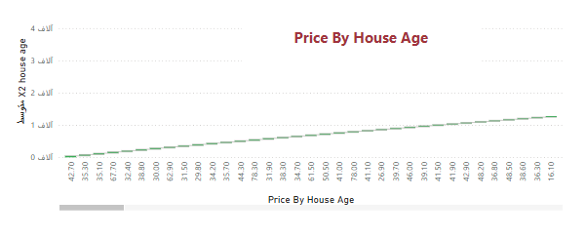

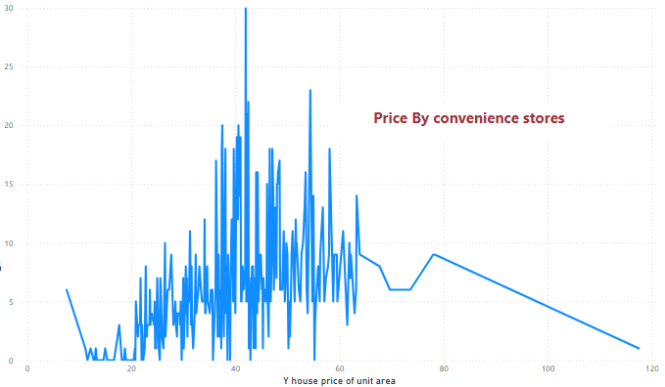

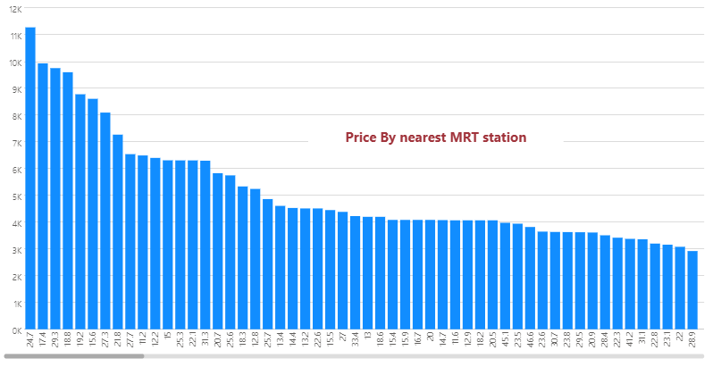

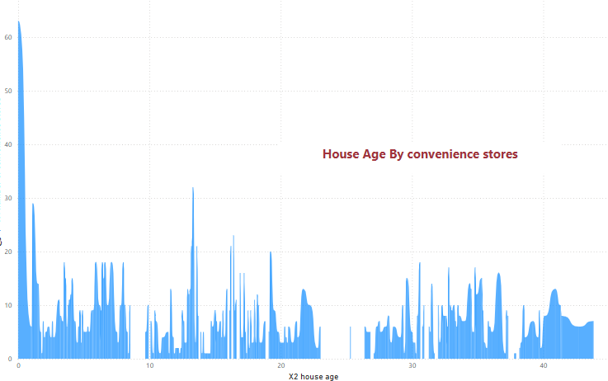

* Model

# K-nearest neighbors (KNN)

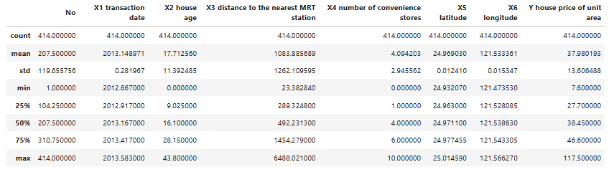

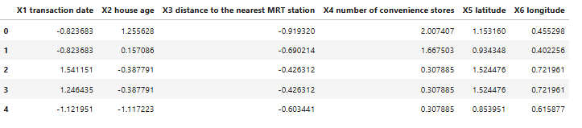

* Results
* Mean Squared Error: 67.8648050225779
* R-squared: 0.5941709799283664